Machine Description | A deliberately vulnerable lab machine for practicing web app exploits, privilege escalation, and post-exploitation to gain user and root access.
Target IP | 192.168.0.175
Vulnerability Name | Multiple Vulnerabilities Leading to Full System Compromise (CMS Authentication Bypass, SMB Null Session Misconfiguration, Credential Exposure)
Port / Service | TCP / http 80  SSH / 22
Severity | Critical (9.3)
Attack Vetor | CVSS:3.0/AV:L/AC:L/PR:N/UI:N/S:C/C:H/I:H/A:H
Proof of Concept (PoC) | STEP 1 – Nmap to find the IP of the target machine.  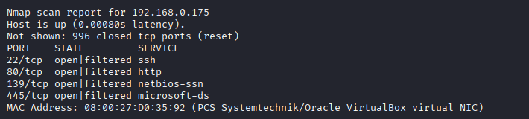  STEP 2 – Nmap Scan to discover open ports and Services  # nmap –p- -sC –sV $ip –open  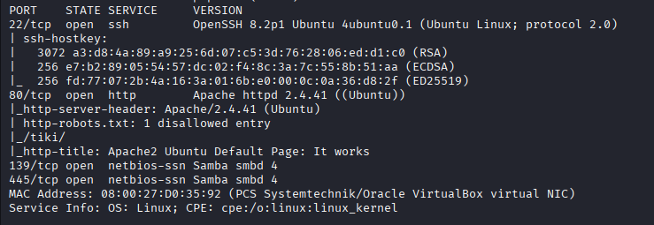  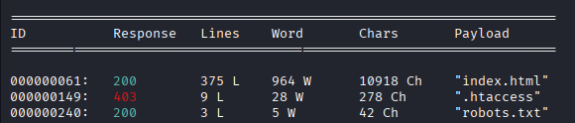  Step 3 – Using wfuzz we found an index.html page :  Step 4 – Found a CMS.  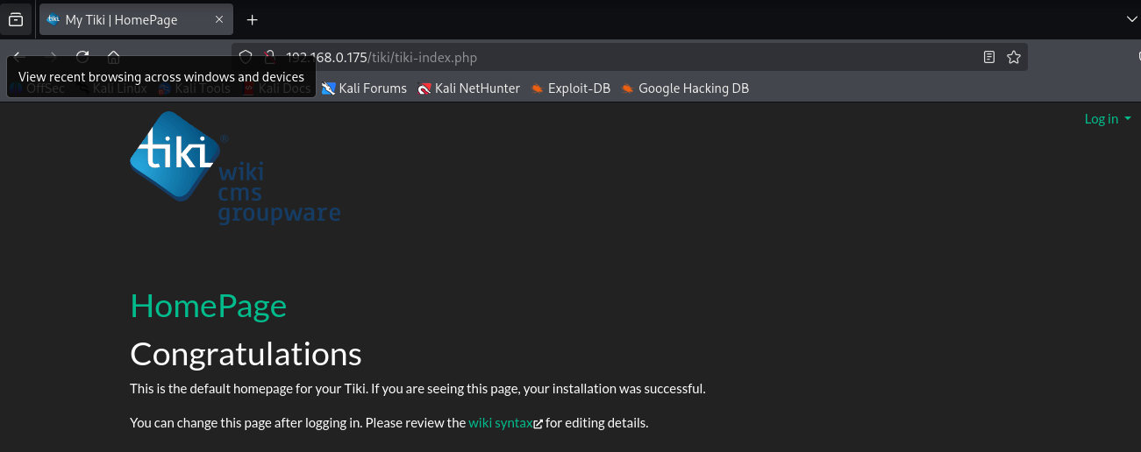  Step 5 – Null sessions founded on SMB.  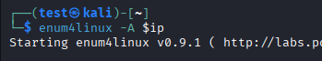  Step 6 – Logged in and retrieve a file.  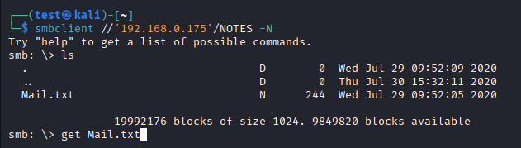  Step 7 – Founded the password for CMS.  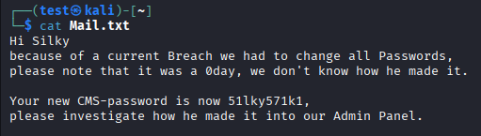  Step 8 – logging in the CMS  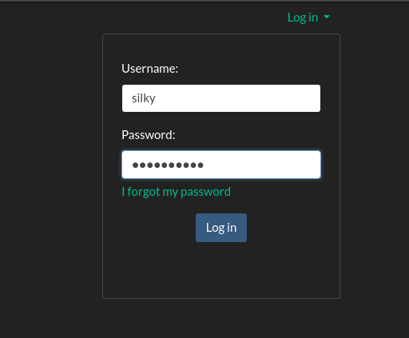  Step 9 – Founded the version in changelog.txt  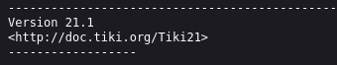  Step 10 – Found a payload for this version.  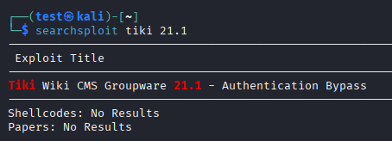  Step 11 – We used that to Bypass authentication for admin.  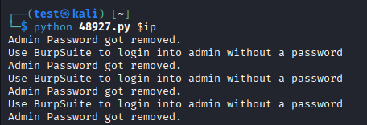  Step 12 – The admin password is removed but we must enter something in the password firld and use Burpsuite to intercept and remove whats in front of “pass” and forward the packet.  Step 13 – We are admin now  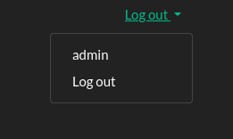  Step 14 – Further we found creds.  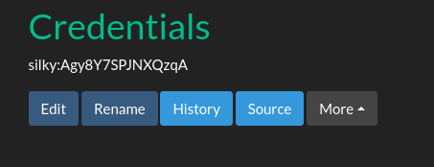  Step 15 – logged in using ssh  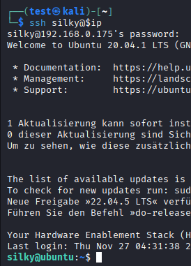  Step 16 – It Seems that silky is a sudoer user.  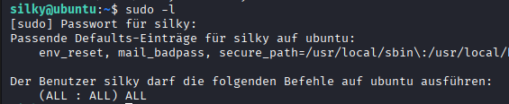  Step 17 – We have Root !  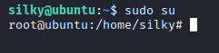  PROOF:  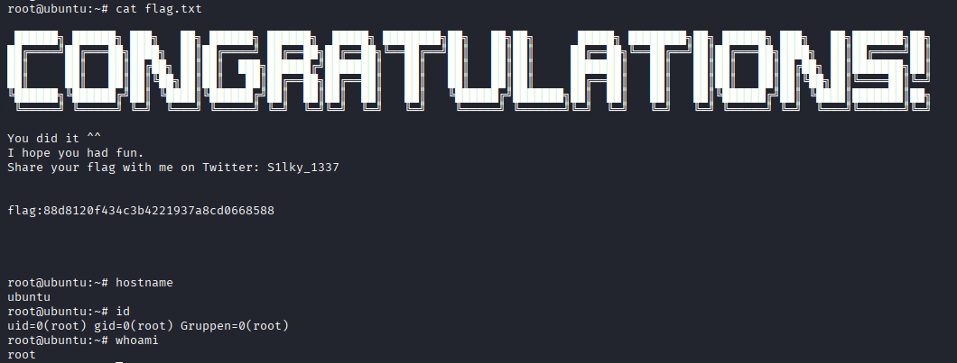
Remediation | • Patch or update the CMS to the latest version to fix the authentication bypass vulnerability.  • Disable SMB null sessions and enforce proper access controls.  • Remove publicly accessible sensitive files and prevent directory listing.  • Enforce strong passwords and rotate all exposed or reused credentials.  • Limit SSH access to authorized users only and use key-based authentication.  • Apply principle of least privilege and update sudoers configuration.
Impact | The attacker can bypass CMS authentication, obtain administrative access, retrieve sensitive files through SMB null sessions, discover system credentials, log in through SSH, escalate privileges, and ultimately gain full root control of the machine. This results in complete loss of confidentiality, integrity, and availability.
References | https://owasp.org/www-project-top-ten/

